Project Name: | P78234_4000A_Super_Shakti_LT_PDB_Panel | Type Of Panel: | Compartmentalized 4000A ACB LT PDB Panel
Project No: | P78234 | Drawing No: | D78234
Client : | SUPER SHAKTI | End User : | Super Shakti
Drawing Title: | 4000A LT PDB Panel | QTY of Panel : | 02 Sections

VISUAL INSPECTION |  |  |  |  |  |  |  |  |  |  |  |  |  |  |  | Reference : |  | As per Approved Drawing
Panel Dimensions (mm) |  | Height |  |  | 2000+75 |  |  |  | Width |  | 3200 |  |  | Depth |  |  | 1000
Sheet Thickness (mm) |  | Casing |  |  | 2&1.6 |  |  |  | Door |  | 2.0 |  |  | Gland Plate |  |  | 3.00
 |  | Component Mounting Plate |  |  |  |  |  |  |  |  | [2.0]
Type of Door |  | Hinge |  |  |  |  |  |  |  | Type of Door Lock |  |  | Front is Compartmentalized and Fancy lock, Rear door is sectionized and Fancy Lock.
Paint of Internal |  | RAL7035 |  |  |  |  |  |  |  | Paint of External |  |  | RAL7035
Components Mounting as per GA |  |  |  | Done Ok |  |  |  |  |  |  |  | Components Mounting as per IGA |  |  |  |  |  |  | Done Ok
Use of Nuts and Bolts as per Required size |  |  |  |  |  | Ok |  |  |  |  |  | Tightness of all Nuts and Bolts |  |  |  |  |  |  | Verified and found Ok
Panel IP |  | IP-42 before assembly |  |  |  |  |  |  | Panel Colour code |  |  |  |  | RAL 7035 |  |  | Components Mounting |  |  | OK
Nameplate |  | OK |  |  |  |  |  |  | Lock & Gasket |  |  |  |  | OK |  |  | Component Labeling |  |  | OK
Electrical Earthing | AVAILABLE |  |  |  |  |  |  | Electronics Earthing |  |  |  |  |  |  | N.A. |  | Wiring |  |  | OK
Terminal Marker | AVAILABLE |  |  |  |  |  | Ferruling |  |  |  |  |  |  |  | OK |  | Crimping & Tightness |  |  | OK

BOM |  |  |  |  |  |  | Reference : | As per Drawing No. D78234
Component Specification as Per Bom |  | Found Ok |  |  | Wire Specification as Per Bom |  |  |  | Found Ok
Wire Color Used as Per BOM |  | Found Ok |  |  | Power Bus Size Used as Per Bom |  |  |  |  | [200x10x3,125x10x2, 80x10x7,80x10x3, 30x10x2,30x10x1, 40x10x2,40x10x1, 30x10x1,30x6x1]
Earth Bus Size Used as Per BOM |  | 50x6 GI |  |  | CT Shorting Link Used/Not |  |  |  | Used
DI Card Used as Per BOM Spec and Qty |  |  | N. A. |  | DO Card Used as Per BOM Spec and Qty |  |  |  |  |  | N. A.
AI Card Used as Per BOM Spec and Qty |  | N. A. |  |  | AO Card Used As Per Bom Spec and Qty |  |  |  |  |  | N. A.
CPU used as Per BOM Spec and Qty |  | N. A. |  |  | Power Supply Used as Per BOM Spec and Qty |  |  |  |  |  |  | N.A.
Signal Isolator Used as Per BOM Spec and Qty |  |  |  | N. A. |  | Transmitter Used as Per BOM Spec and Qty |  |  |  |  |  | N.A.
ACB Used as Per Bom Spec and Qty |  | 4000A ABB |  |  | Relay /Contactor Used with Required No/Nc |  |  |  |  |  |  | Found Ok as per drawing
BUS BAR
Supporting Insulators Are Adequate/Non-Adequate |  |  | Adequate | Bus Bar Joints Tightness | Found Ok
Bus Bar Gap |  | 16-30mm |  | Bus Bar Color Identification | R Y B & Bk Heat Shrink Sleeve

COLD TESTING
Continuity Test of All Terminals as Per Drawing |  |  |  | As per circuit drawing found Ok | CT Shorting Link Connection | Shorting Done
CT Connection Polarity |  | Checked and Found Ok |  |  | All Terminals Tightness | Checked and Found Ok.
MCCB, ACB Etc. O/C Function Adjustment |  |  | To be done as per field application |  | Earth Continuity | Ok
Megger Testing |  | Average 1.8M Ohm Before and after with 1000V Megger] |  |  | HV Testing | Average 1.1KV in all respect for 1min.]

HOT TESTING
Functional Checking of All Individual Branch of Circuit |  |  |  |  |  | Found Ok as per drawing, Applied Incomer 415V AC and Control Supply is 230V AC through control transformer. Total control circuit checked and found Ok.
Parameterization Of All Digital Instruments |  |  |  | done |  |  | CPU Function | N.A.
Force Input of All DI And DO | N.A. |  |  |  | Force OP of All AI and AO With Injector |  |  | N.A.
PLC Logic Testing by Simulation |  | N.A.
INSTRUMENTS USED |  |  | Digital Multi Meter, Meger, Digital HV test kit.
RECOMMENDATION OF TESTING ENGINEER
Panel Tested by Client Inspector and PISPL Engineer. Found Satisfactory. Panel is ready to dispatch.

FINAL ACCEPTANCE | ACCEPTED | DISPATCH CLEARENCE | CLEARED | AS MANUFACTURE DRWING | PREPARED

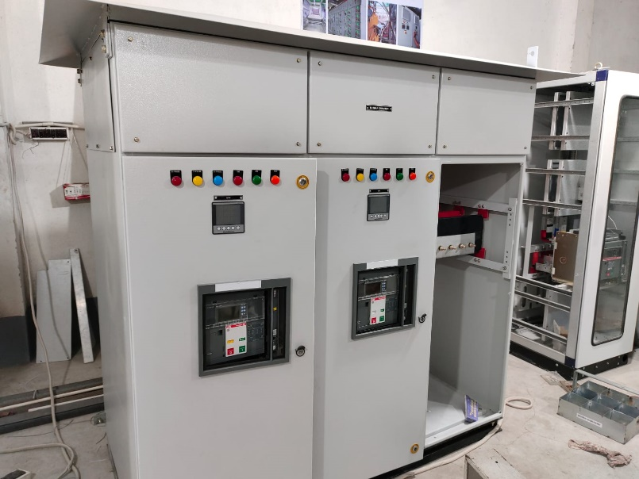 | 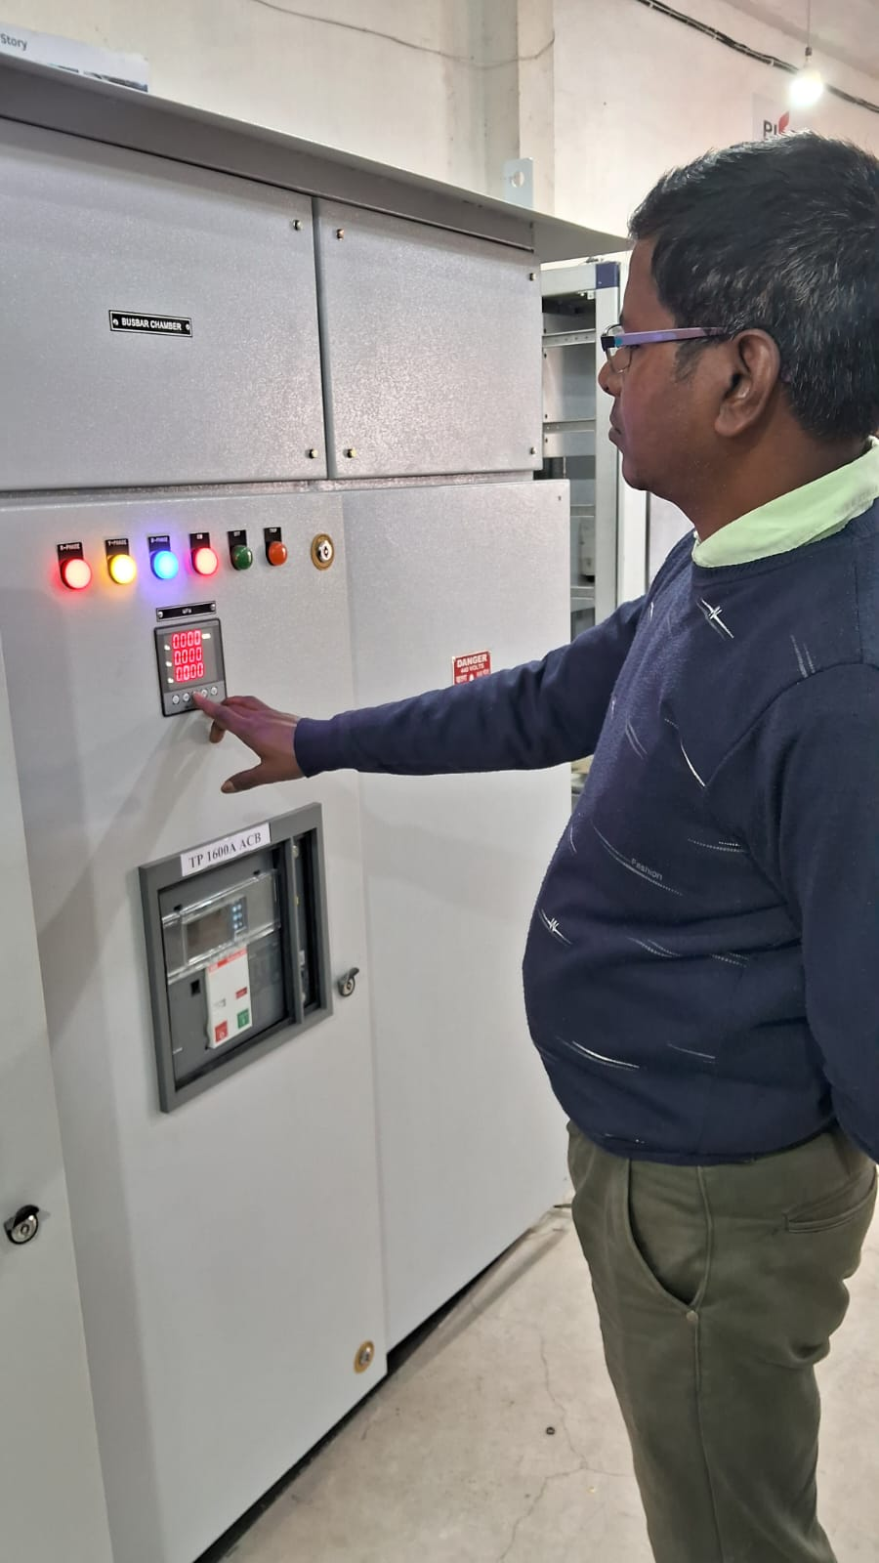
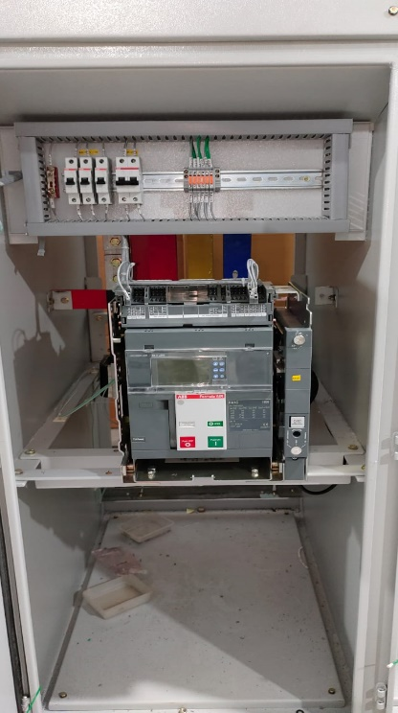 | 